Sign up for Electronic Giving and never forget your envelope again!

Complete this form, print and mail to Deb at the Church office or drop in the collection basket.
St. Mary of the Assumption
P.O Box 68
West Point, Iowa 52656

I/We would like to use Electronic Funds to make contributions to
St. Mary of the Assumption Catholic Church Holy Trinity Catholic School
I/We authorize the church to initiate an Electronic Funds transfer of $
from the account indicated below every: Week (Monday) Month (2nd Monday) Month(4th Monday)
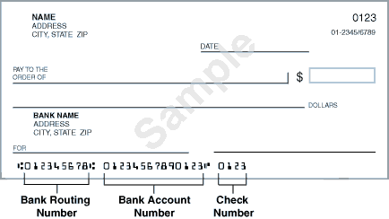

Your Bank’s Name:
Your Bank’s Routing Number:
Your Bank’s Address:
Your Bank’s Phone:
Your Account Name:
Your Account Number
Account Type: Checking Savings
Church Envelope #

To help us avoid incorrect information please attach a voided check or deposit slip from your checking/savings account.
I/We may cancel this agreement by giving written notice to the church.

Signed: Date:
Printed Name:
Signed: Date:
Printed Name:
Sign up for Electronic Giving save paper and never forget your envelope again!
I/We would like to use Electronic Funds to make contributions to
St. Mary’s Church Holy Trinity School
I/We authorize the church to initiate an Electronic Funds transfer of $ to the account indicated every.
Week (Monday)Month (2nd Monday)Month(4th Monday)
Your Bank’s Name
Your Bank’s Routing Number
Your Bank’s Address
Your Bank’s Phone
Your Account Name
Your Account Number
Church Envelope #
Account Type: Checking Savings
To help us avoid incorrect information please attach a voided check or deposit slip from your checking/savings account.
I/We may cancel this agreement by giving written notice to the church.

Signed: Date:
Printed Name
Signed: Date:
Printed Name
Sign up for Electronic Giving save paper and never forget your envelope again!
I/We would like to use Electronic Funds to make contributions to
St. Mary’s Church Holy Trinity School
I/We authorize the church to initiate an Electronic Funds transfer of $ to the account indicated every.
Week (Monday)Month (2nd Monday)Month(4th Monday)
Your Bank’s Name
Your Bank’s Routing Number
Your Bank’s Address
Your Bank’s Phone
Your Account Name
Your Account Number
Church Envelope #
Account Type: Checking Savings
To help us avoid incorrect information please attach a voided check or deposit slip from your checking/savings account.
I/We may cancel this agreement by giving written notice to the church.

Signed: Date:
Printed Name
Signed: Date:
Printed Name
Sign up for Electronic Giving save paper and never forget your envelope again!
I/We would like to use Electronic Funds to make contributions to
St. Mary’s Church Holy Trinity School
I/We authorize the church to initiate an Electronic Funds transfer of $ to the account indicated every.
Week (Monday)Month (2nd Monday)Month(4th Monday)
Your Bank’s Name
Your Bank’s Routing Number
Your Bank’s Address
Your Bank’s Phone
Your Account Name
Your Account Number
Church Envelope #
Account Type: Checking Savings
To help us avoid incorrect information please attach a voided check or deposit slip from your checking/savings account.
I/We may cancel this agreement by giving written notice to the church.

Signed: Date:
Printed Name
Signed: Date:
Printed Name

